
SRM Institute of Science and Technology
Mode of Exam
OFFLINE
College of Engineering and Technology
School of Computing
DEPARTMENT OF COMPUTATIONAL INTELLIGENCE
SRM Nagar, Kattankulathur – 603203, Chengalpattu District, Tamilnadu
Academic Year: 2022-23 (EVEN)
Test: CLAT-2 Date: 04.04.2023
Course Code & Title: 18AIC209T Foundation of Metric Spaces Duration: 1 hour
Year & Sem: II Year & IV Semester Max. Marks: 25 Marks
Course Articulation Matrix: (to be placed)
Course Learning Outcomes (CO): |  |  |  |  |  | At the end of this course, learners will be able to:
CO-1 : |  | Discover whether examples of metric spaces are complete using Cauchy sequences
CO-2 |  | Understand iterative processes on general spaces
CO-3 |  | Can apply principles and algorithms to evaluate models generated from data
Program Learning Outcomes (PLO)
1 | 2 |  | 3 | 4 | 5 |  | 6 | 7 | 8 | 9 | 10 | 11 | 12 | PSO
Engineering Knowledge | Problem Analysis |  | Design & Development | Analysis, Design, Research | Modern Tool Usage |  | Society & Culture | Environment & Sustainability | Ethics | Individual &Team Work | Communication | Project Mgt. & Finance | Life Long Learning | PSO - 1 | PSO - 2 | PSO – 3
3 | 2 |  | 2 | 3 | - |  | - | 1 | - | - | 3 | 2 | 2 | 2 | 2 | 2
3 | 3 |  | 3 | 2 | 3 |  | - | 2 | 1 | - | 3 | 3 | 2 | 2 | 2 | 2
3 | 3 |  | 2 | 3 | 3 |  | 2 | 2 | 2 | 1 | 3 | 2 | - | 2 | 2 | 2

Part - A
(10 x 1 = 10 Marks)
Instructions: Answer all
Q. No | Question | Marks | BL | CO | PO | PI Code
1 | A function f : X → Y is a __________ if f is continuous, one-one, and onto with continuous inverse  - Homeomorphism  - Isometric  - Bi-Lipschitz Equivalent  - None of These | 1 | 1 | 2 | 1 | 2.1.1
2 | The Euclidean metric is related by the inequality __________  - None of these | 1 | 1,2 | 2 | 1,2 | 2.1.3
3 | The subspace (X, d) is a __________ metric space if and only if X is a closed subset of M.  - Complete  - Isometric  - Compact  - Homeomorphic | 1 | 1 | 2 | 1 | 1.1.1
4 | A bijective map A : X → Y is open if and only if __________  - A : X →Y is invertible  - A : X →Y is bounded  - A⁻¹ : Y →X is bounded  - A⁻¹ : Y →X is open
5 | A function 𝑓:𝑋1→𝑋2 is called isometry if __________  - 𝑑₁(𝑥,𝑦)≠𝑑₂(𝑓(𝑥),𝑓(𝑦)) ∀𝑥,𝑦∈𝑋₁  - 𝑑₁(𝑥,𝑦)=𝑑₂(𝑓(𝑥),𝑓(𝑦)) ∀𝑥,𝑦∈𝑋₁  - 𝑑₁(𝑥,𝑦)<𝑑₂(𝑓(𝑥),𝑓(𝑦)) ∀𝑥,𝑦∈𝑋₁  - 𝑑₁(𝑥,𝑦)>𝑑₂(𝑓(𝑥),𝑓(𝑦)) ∀𝑥,𝑦∈𝑋₁ | 1 | 1 | 2 | 1,2 | 2.1.1
6 | The topology of a set containing only ∅ and the set itself is called _________  (a)Discrete topology  (b)Indiscrete topology  (c)Trivial topology  (d) Order Topology | 1 | 1 | 3 | 1 | 1.1.1
7 | If A and B are two subsets of a topological space, (X,τ) and they are disjoint. Then what will be A∩B?  - ϕ  - A∪B  - X  - None of these | 1 | 1 | 3 | 1,2 | 2.1.1
8 | Every finite point set in a Hausdorff space S is __________  - Closed  - Open  - Hausdorff  - Connected | 1 | 1 | 3 | 1 | 1.1.1
9 | The space [0, 1]^{ω} with the product topology is __________  - Bounded  - Unbounded  - Finite  - Metrizable | 1 | 1 | 3 | 1 | 1.1.1
10 | The topology of a set equal to the power set of the set is called ________  - Discrete topology  - Indiscrete topology  - Trivial topology  - Both b and c | 1 | 1 | 3 | 1 | 1.1.1
Part – B
(3 x 5 = 15 Marks)
Instructions: Answer any 3
11 | Prove that every open ball in a metric space (X,d) is an open set in (X,d). What about the converse? Justify. | 5 | 4 | 2 | 1,2 | 2.4.1
12 | Write the definition and properties of Hilbert’s space-filling curves. | 5 | 2 | 2 | 1,2 | 2.4.1
13 | Let (X, τ ) be a topological space and A ⊆ X a subset. Describe the interior of A (denoted int(A)) and the closure of A (denoted cl(A)). | 5 | 3 | 3 | 1,2 | 2.4.1
14 | Show what it means for a topology τ on X to be Haursdoff. | 5 | 2 | 3 | 1,2 | 2.4.1

*Performance Indicators are available separately for Computer Science and Engineering in AICTE examination reforms policy.

Course Outcome (CO) and Bloom’s level (BL) Coverage in Questions

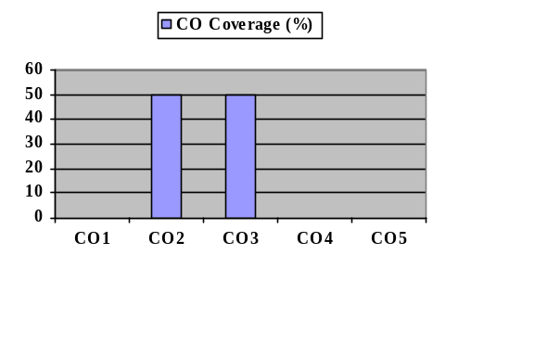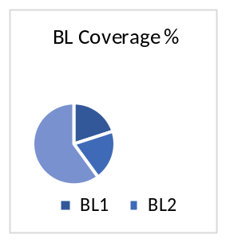
Approved by the Audit Professor/Course Coordinator

